A distribution free analysis on Hollywood movies: were older movies just better?
Motivation:
Me and my friends often have discussions about movies. We’ll watch a movie from 10 years ago, and, inevitably, one of my friends will say something along the lines of “They just made movies better back then”. I am not so sure, so I am going to employ non-parametric methods on movie data from different decades to see if old movies really were better.
Introduction:
I have collected a sample of 500 movies from 5 different decades (100 movies from each decade). The 1980s, 1990s, 2000s, 2010s, and 2020s (2020-2025). These data were obtained from the platform “The Movie Database” which I will abbreviate as TMDB from now on. Each movie has an average rating on the website. I filtered for movies that have at least 100 reviews using their non-commercial API.
To answer my question, I will be using the Kruskal-Wallis distribution free test for one-way layout problems. There are a number of Assumptions we have to verify before employing this method though.
The first is that the N observations {X_1j, X_2j, … , X_nj} j = 1,…,k are mutually independent. For the sake of this analysis, this assumption holds since knowing the average rating of one movie is not going to give you any information about another movie’s rating.
Next, we need to verify that our data comes from continuous distributions. The distribution comes from the average movie ratings that vary from 0 to 10. Since any value is possible, the distribution of each decade’s movies is indeed continuous.
Lastly, the Kruskall-Wallis method assumes that each distribution is identical except for shift in location. This means that we need to verify that the distributions have the same shape and scale. To answer this question, I started with side-by-side boxplots for each distribution.
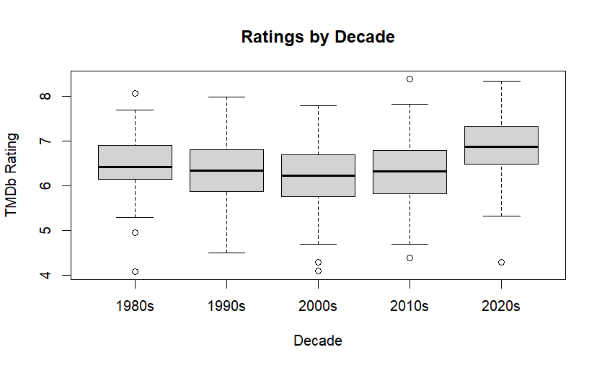

The box-plots largely look like they have similar Interquartile ranges. The 2020s look like they may have a location shift, and the 1980s look like they might have a smaller IQR than the other decades, but nothing that immediately raises red flags for me. For further verification, I generated summary statistics about the standard deviation and IQR for each decade as entailed in the table below.
 | 1980s | 1990s | 2000s | 2010s | 2020s
SD | .624 | .685 | .821 | .789 | .68
IQR | .756 | .9165 | .921 | .947 | .838

Once again, I am happy with these numbers. There aren’t any large outliers in these statistics, but this only gives us a sense of scale for each respective decade’s distribution. To get an idea of the shape of each distribution, I generated density plots of each decade's distribution.
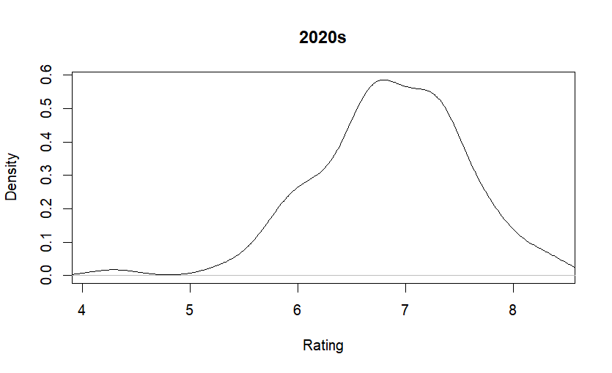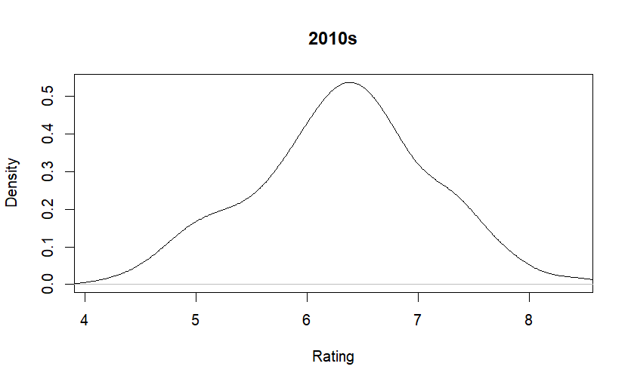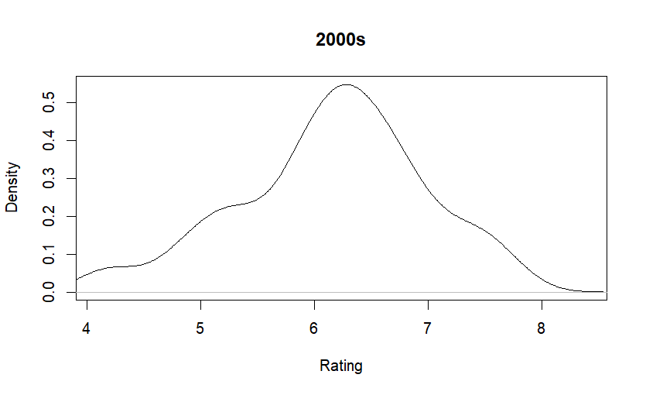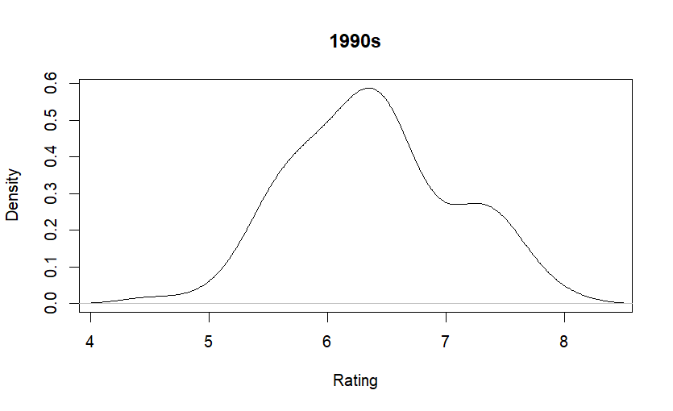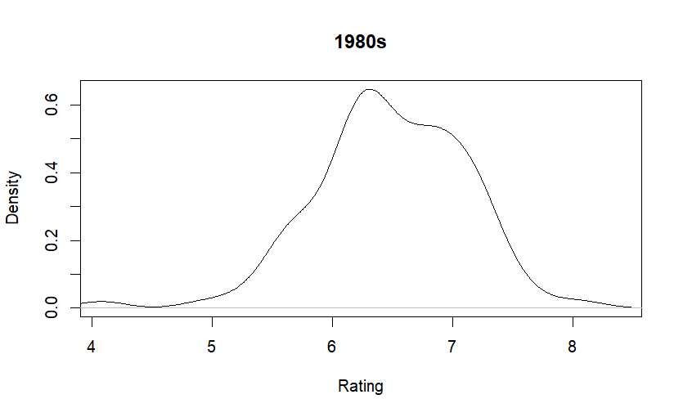
Looking at these density plots, I see that each distribution has one peak with tails that taper off the farther from the center they are. I am hesitant to say that these distributions are approximately normal. To verify that, I would need to generate QQ-plots and run a Shapiro-wilk test on my data. Luckily, for kruskall-wallis, we are not concerned with normality, but rather only if the distributions have the same shape and scale
Analysis:
My calculation for the H statistic for the Kruskall-Wallis test was 47.223. Since there were ties in the data, I also applied a correction factor of 1 / .9998521 which is approximately 1.000148. I think my large sample size minimized any impact of ties. My final H statistic was 47.229.
Given my large sample size, I used the large sample approximation for the p-value which says I may reject the null hypothesis if my H statistic is greater than a critical value derived from a chi-squared distribution with 4 degrees of freedom. The critical value I obtained was 11.14329. Since 47.229 is larger than 11.14329 we reject the null hypothesis that all treatment effects are equal. At least one treatment effect is different than the others.
Given my original question, I was not concerned with each pairwise comparison. I only wanted to determine if movies from the 2020s are better or worse than movies from previous decades. To this end, I performed a Wilcoxon rank-sum test between the 100 movies from the 2020s and the 400 movies from the other decades. This yielded a W statistic of 28164 and a p-value of 2.664e-10. A point estimate of the difference in location is 0.524 with a confidence interval of (0.377, 0.685).
Monotonicity:
Comment 9 of our textbook brings up the issue of monotonicity in the context of the Kruskall-wallis test. From the paper he cited (Gabriel, 1969), the definition of monotonicity of a family of tests is as follows:
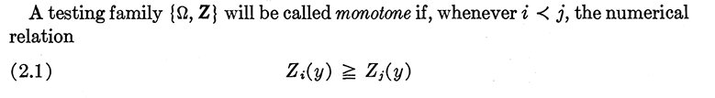
The notation of i < j is indicating that the ith hypothesis is more specific than the jth hypothesis. The comparison of Zi(y) >= Zj(y) is saying that the critical point for the stronger test is greater than or equal to the critical point of the weaker/less specific test.
When a family of tests are monotone, then they are considered to be coherent. For example, if we are testing the null hypothesis H0_1: θ1 = θ2 = θ3 as well as the test H0_2: θ1 = θ2, we would expect the critical point for H0_1 to be greater than H0_2 since if all three medians are equal then θ1 and θ2 would also have to be equal. In other words, since H0_2 is a subset of H0_1, we would expect H0_2 to be easier to reject than H0_1. This property is not present in the kruskall-wallis test.
But, since we are not performing a family of tests, we don’t need to be concerned about the coherency of our conclusion. Additionally, Gabriel mentions that the kruskall-wallis method tends to be coherent with large enough sample sizes. He goes so far as to call the kruskall-wallis method “asymptotically coherent”.
Pairwise comparisons:

